**Shop**Bridge Programming Assignment

By Nikhil Jojare

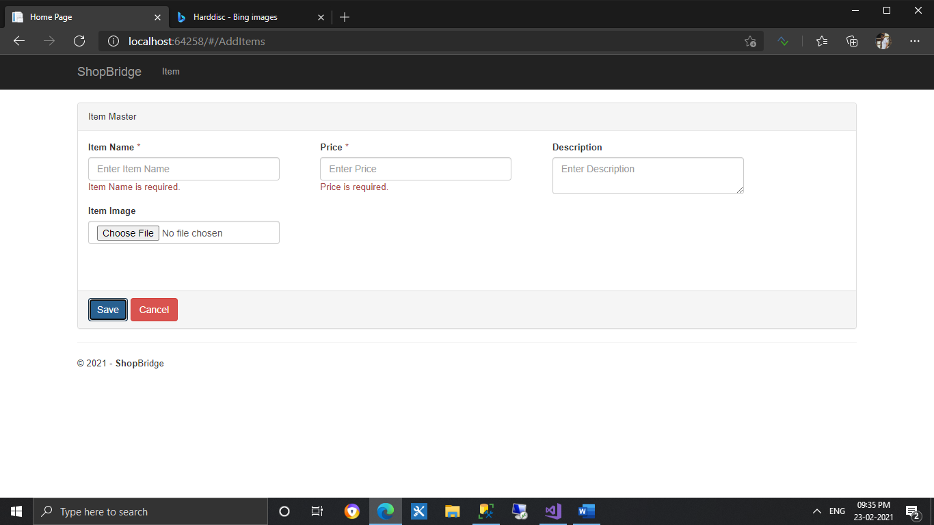

1. Add Item (Handled Validation)

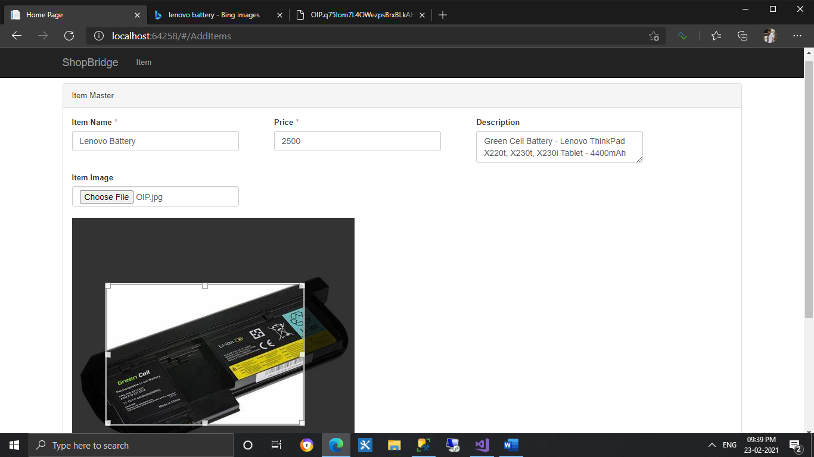

1. Added Crop and Save Image Functionality for Item Image.

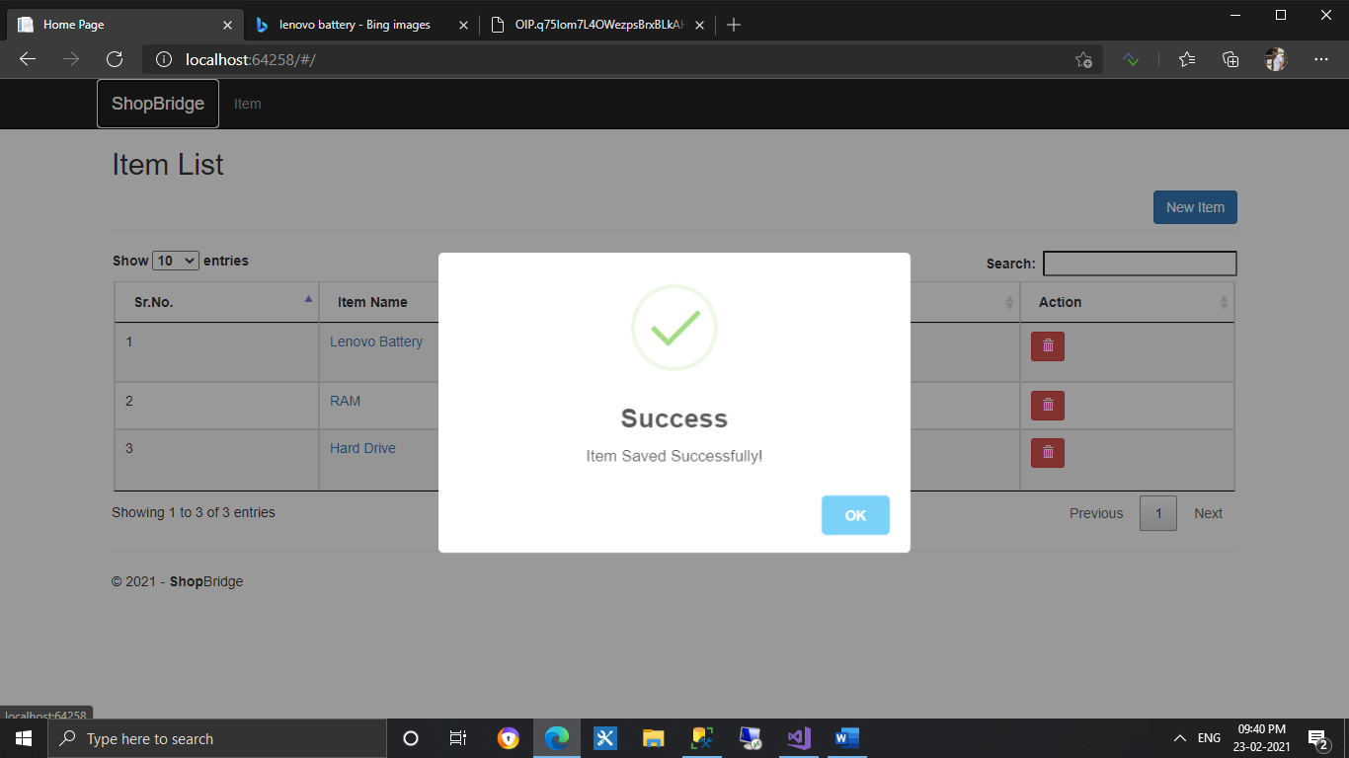

1. Alert message on successfully item saved

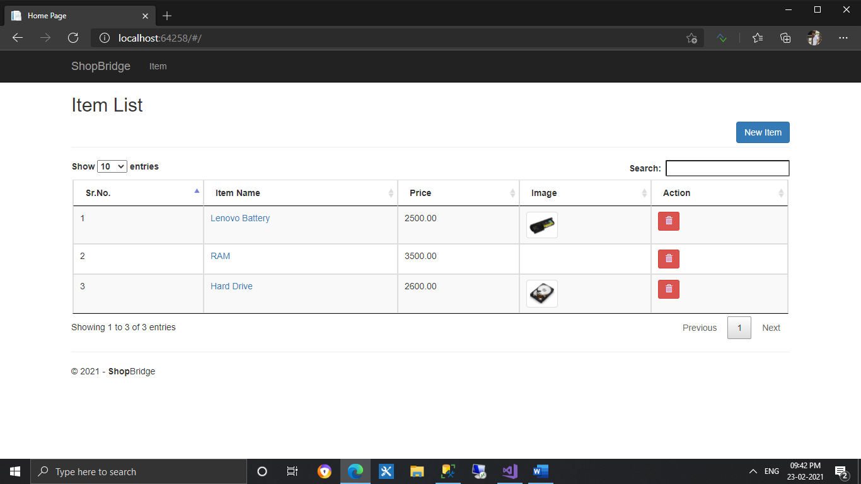

1. Item Dashboard (With Search, Sort, Pagination)

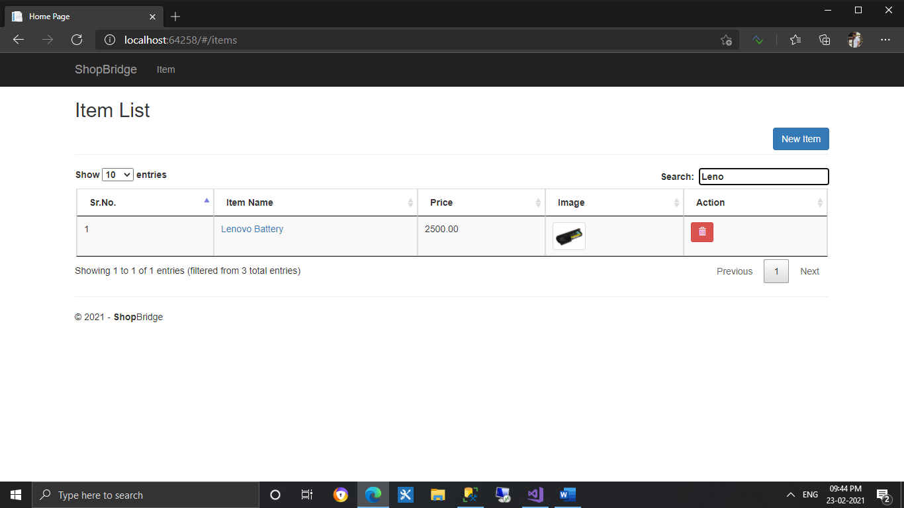

1. Search Functionality with lenovo word

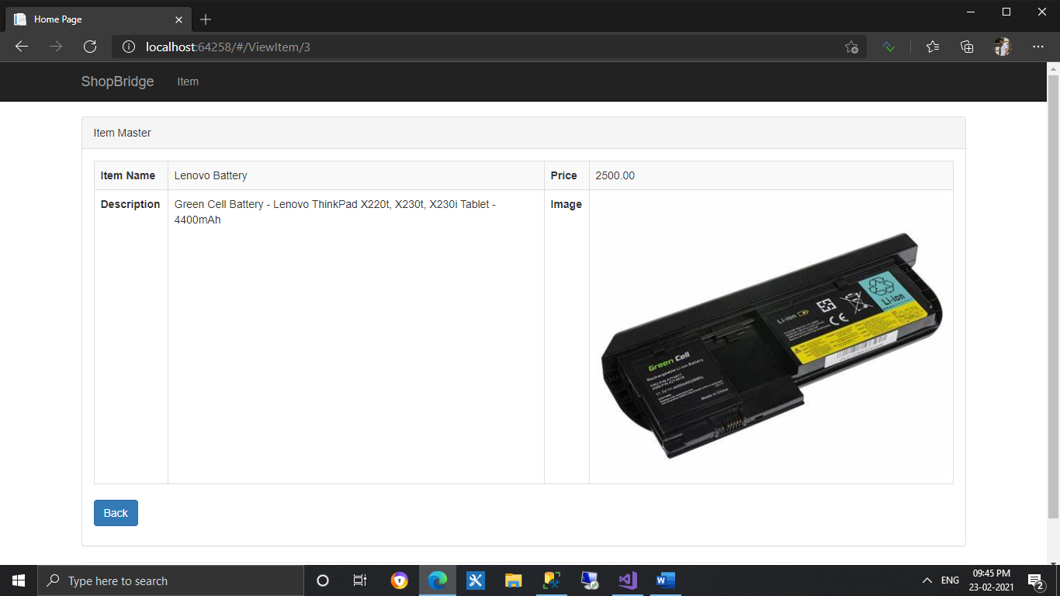

1. View Item on click Item Image from dashboard

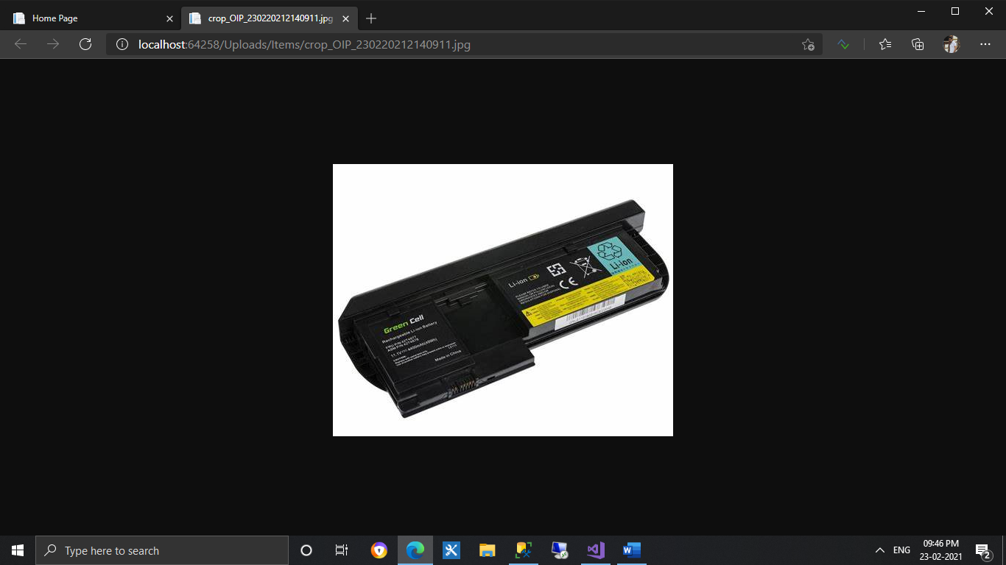

1. View Image on click Image from dashboard

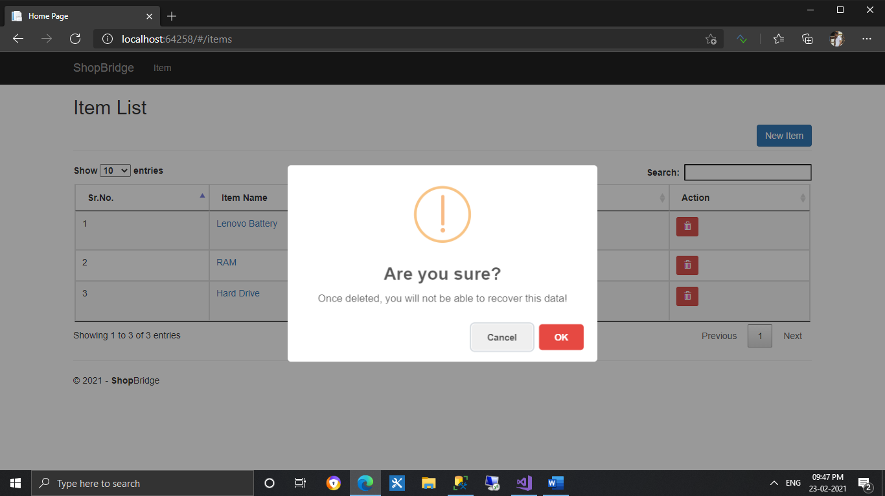

1. Delete Confirmation message for delete item

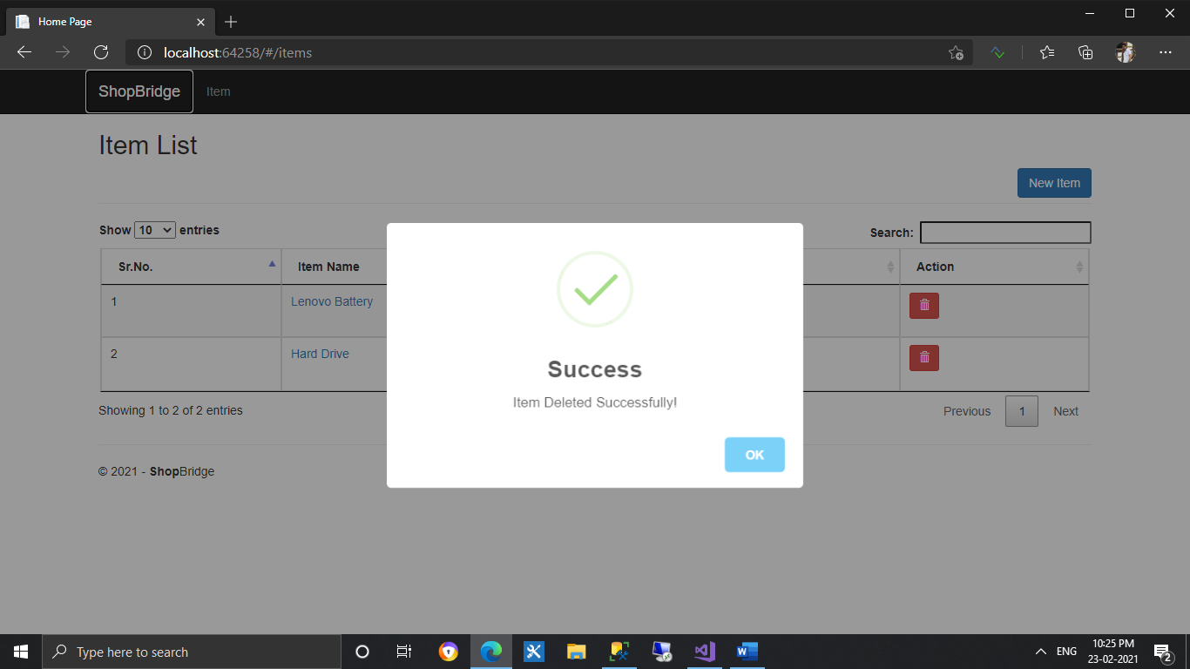

1. Alert message on item deleted successfully

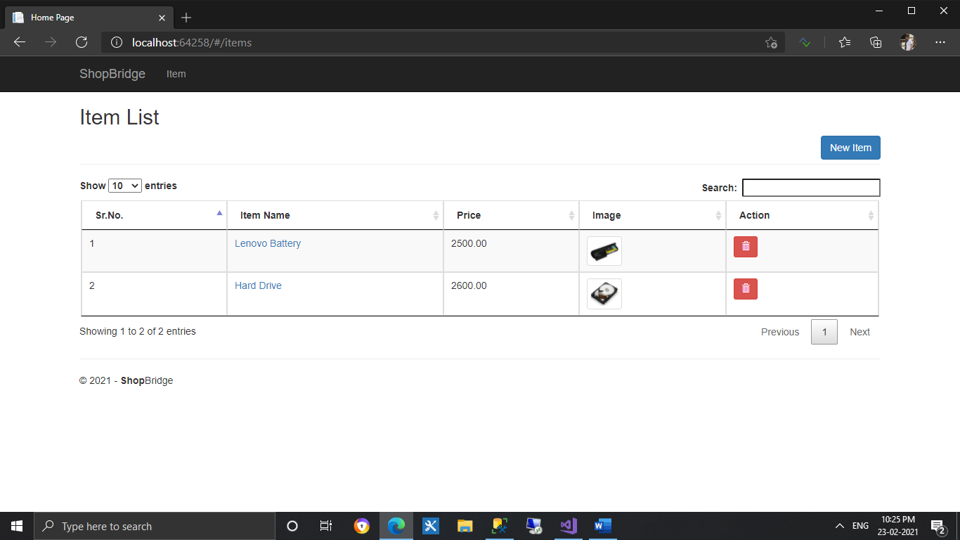

1. Dashboard after item delete